Minor Project



*Facial Recognition*

Submitted by

**AKASH HARIPRIYA**

**ASHISH KARAMCHANDANI**

**ABHINAV SAINI**

Student of

*B.Tech CSE-A (Fifth Semester)*

in

Oriental College Of technology, Bhopal

Table of Contents

Page No.

1. **Title of the project 3**
2. **Introduction 3**
3. **Objective 3**
4. **Future of Facial Recognition Attendance System 3**
5. **Project Scope 4**
6. **Applications 4**
7. Disadvantages of face recognition 4
8. **Future of Facial Recognition 5**

**9. Technical Requirements 5**

10. Facial recognition Lifecycle / Flow Chart 6

11. Project Screenshots 7

12. **Bibliography** 9

* **Websites 9**
* **Books/e-books 9**

# Title of the project

Real Time Facial Recognition

# Introduction

* Facial recognition is a way of identifying or confirming an individual’s identity using their face. Facial recognition systems can be used to identify people in photos, videos, or in real-time.
* Facial recognition is a category of [biometric security](https://www.kaspersky.com/resource-center/definitions/biometrics). Other forms of biometric software include voice recognition, fingerprint recognition, and eye retina or iris recognition. The technology is mostly used for security and law enforcement, though there is increasing interest in other areas of use.
* Many people are familiar with face recognition technology through the FaceID used to unlock iPhones (however, this is only one application of face recognition). Typically, facial recognition does not rely on a massive database of photos to determine an individual’s identity — it simply identifies and recognizes one person as the sole owner of the device, while limiting access to others.

# Objective

# In this we are presenting the Attendance System Project Using Face Recognition. Basically, to implement Student attendance system based on the face recognition of webcam’s image in the classroom.

# Future of Facial Recognition Attendance System

* In all the biometric modalities – fingerprint, expression, gait, behavioural, DNA, and others – face is gaining adoption faster. Because, it is not only convenient for almost all to use, but a face provides a sensor (here, camera) and device with too much “signal” or data as any other tool. For example, fingerprints can not suit the many differences in the forms, sizes, distinctive marks, and other distinguishing features of a qualified A.I. program, for all their simplicity and apparent sophistication.
* More commonly, the face is often simpler to use in several situations where sunlight, temperature, social restrictions, and physical access to a mobile device will preclude a person from talking to their phone or utilizing a fingerprint reader. Once the technology is fully developed, implemented, and introduced, facial recognition and face authentication can be taken to new heights.

# Project Scope

* Attendance system using face recognition is a procedure of recognizing students by using face biostatistics based on the high-definition monitoring and other computer technologies. The development of this system is aimed to accomplish digitization of the traditional system of taking attendance by calling names and maintaining pen-paper records.

# Applications

* **Helps find missing people and identify perpetrators:** Law enforcement agencies use facial recognition to identify criminals with no other means of identification and find missing people by comparing faces on live camera feeds with those on a watch list.
* **Strengthens security measures in banks and airports:** t’s been a regular part of airport security screening for years. Similar to identifying criminals that come into shops, the software has helped identify criminals and potential threats to airlines and passengers.
* **Makes shopping more efficient:** Instead of making cash or credit purchases at stores, facial recognition technology can recognize your face and charge the goods to your account.
* **Reduces the number of touchpoints:** It limits touchpoints when unlocking doors and smartphones, getting cash from the ATM or performing any other task that generally requires a PIN, password or key.

# Disadvantages of face recognition

* Massive data storage burden. The ML technology used in face detection requires powerful [data storage](https://searchstorage.techtarget.com/definition/storage) that may not be available to all users.
* Detection is vulnerable. While face detection provides more accurate results than manual identification processes, it can also be more easily thrown off by changes in appearance or camera angles.
* A potential breach of privacy. Face detection's ability to help the government track down criminals creates huge benefits; however, the same surveillance can allow the government to observe private citizens. Strict regulations must be set to ensure the technology is used fairly and in [compliance](https://searchdatamanagement.techtarget.com/definition/compliance) with human privacy rights.

# Future of Facial Recognition

* There are currently no regulations in the United States expressly covering biometric data of a person. Facial recognition devices are already being tested or implemented for airport protection, and it is reported that their faceprint has now been produced by more than half the United States populace. Information may be collected and processed by a facial recognition program, and a person does not even recognize it. Then, a hacker might reach the details, and the knowledge of a person would propagate without even realizing it. Government entities or marketers may use this data to monitor individuals too. Worse still, a false positive may include a person for a crime they are not.
* Hundreds of companies have embraced face recognition. Integrating and installing is reasonably straightforward, but it has also provided users a feeling of utilizing a system that is more sophisticated and safer than passwords or PINs, thereby increasing user experience. Nonetheless, plenty is often unclear on the road to implementing what many deem the ideal biometric approach, causing several relatively severe blunders along the way.

# Technical Requirements

* Webcam for face recognition
* Software requirements: Visual Studio Code, Git
* library requirements: Cmake, numpy, facial recognition, OpenCV, dlib
* Languages used: Python
* RAM: 4 GB(minimum) and we can assign maximum any size of RAM as per our requirement.
* Hard Disc: nGB depending upon the requirement to store the data. We have assigned 40 GB for our project.

# Facial recognition Lifecycle / Flow Chart

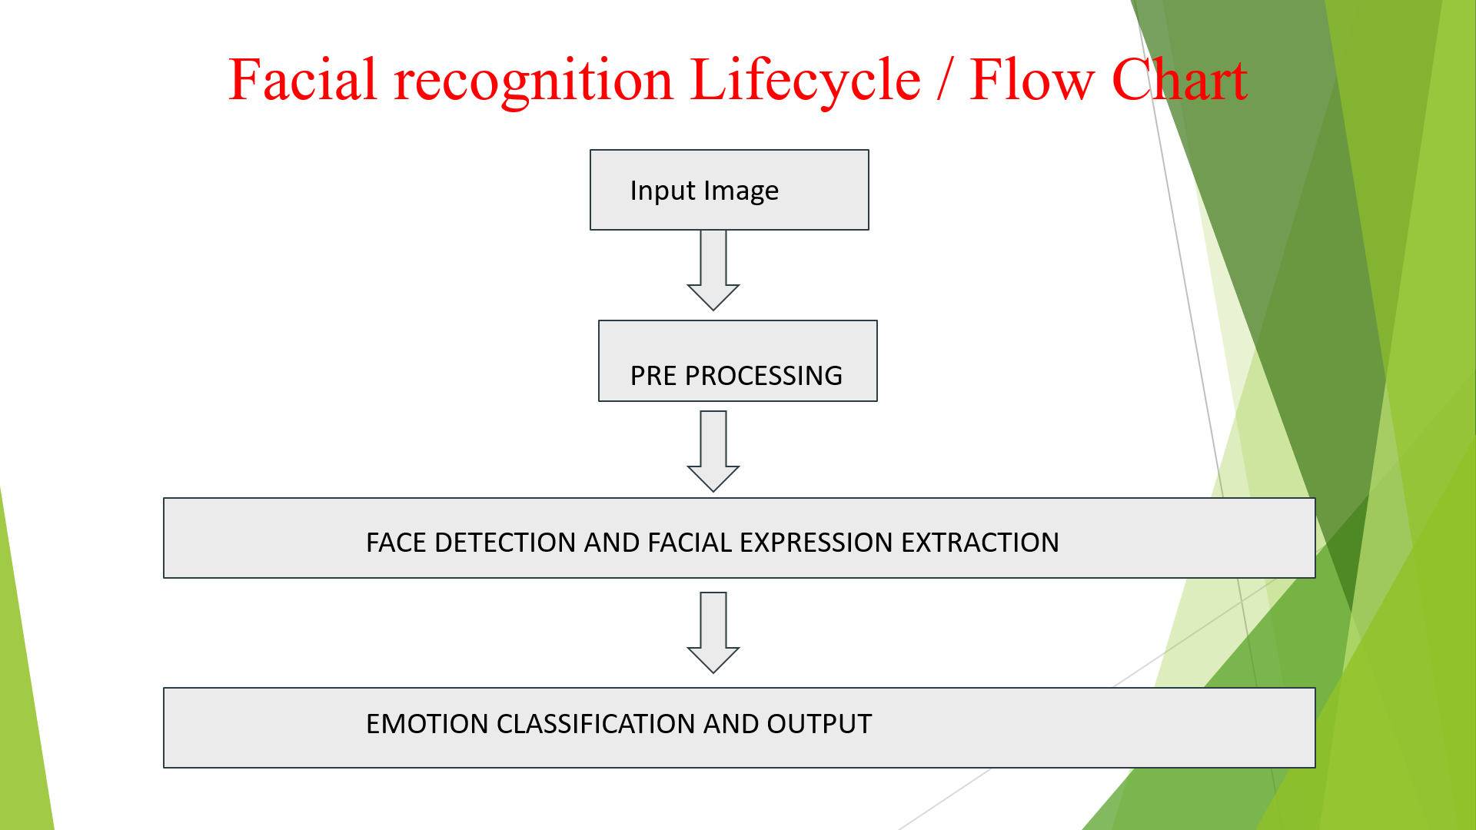

# 

# Project Screenshots

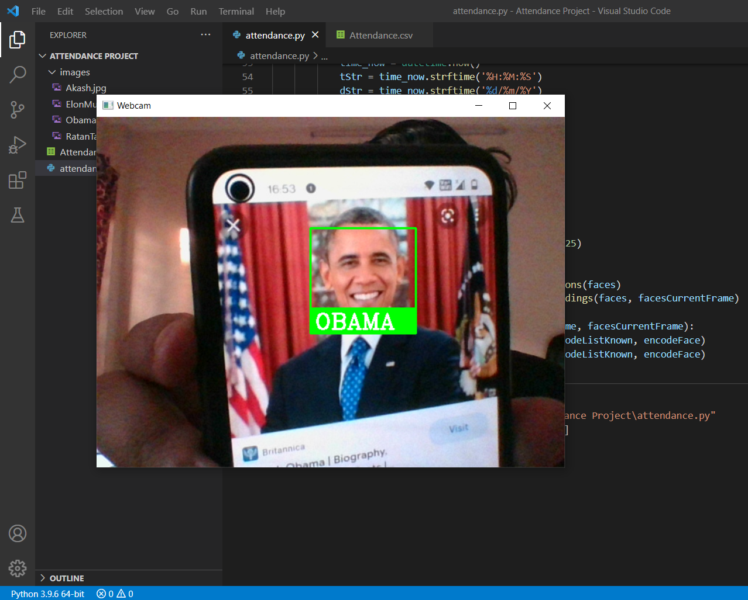

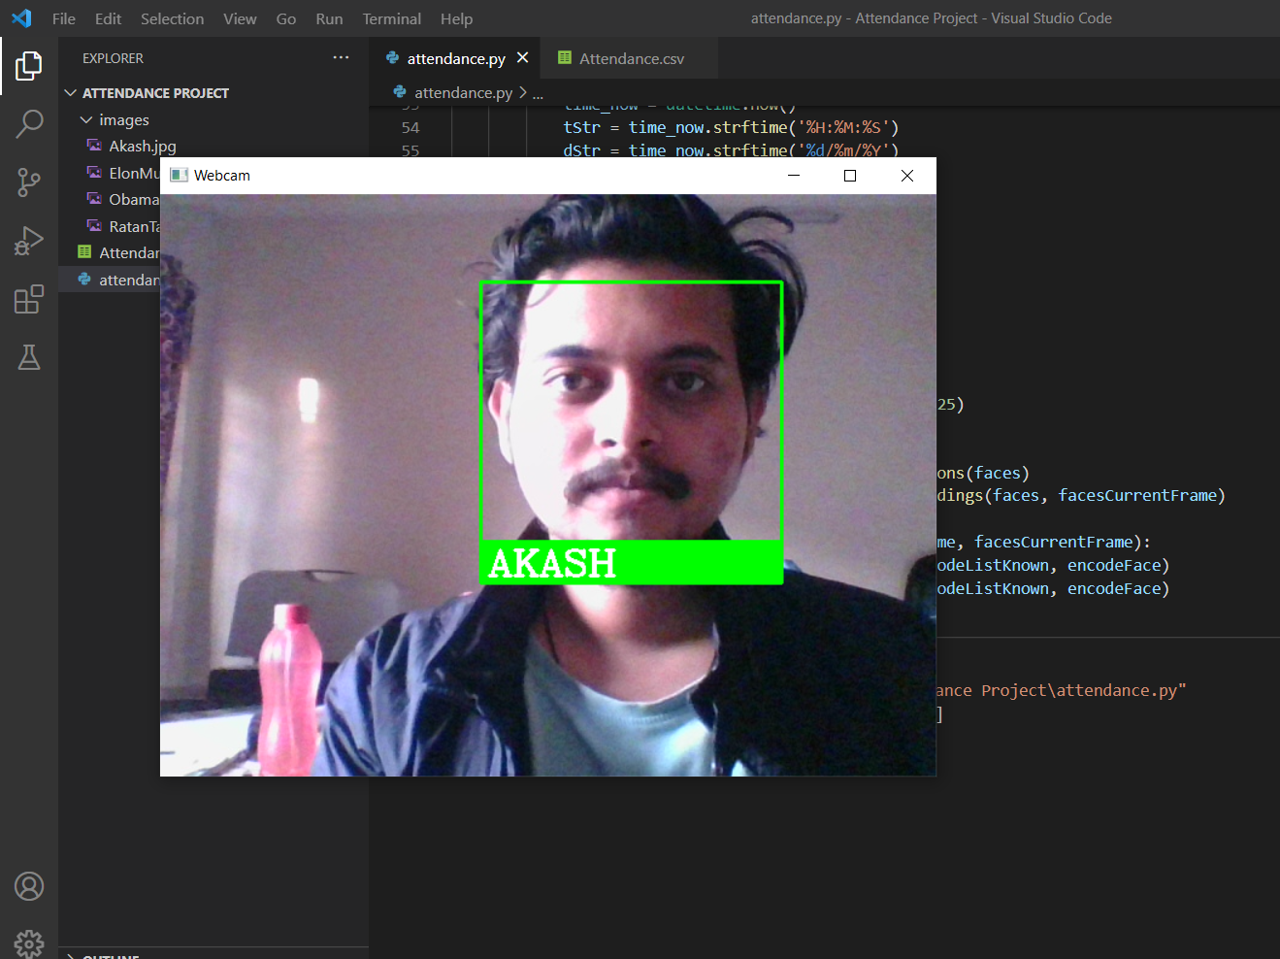

# Bibliography

# ● Websites

Following websites has been referred to create this project report:

* <http://www.google.com/>
* <http://www.vmware.com/>
* https://en.wikipedia.org/
* https://www.geeksforgeeks.org/python-face-recognition-using-gui/
* <https://www.kaspersky.com/resource-center/definitions/what-is-facial-recognition>
* YouTube: <https://www.youtube.com/watch?v=sz25xxF_AVE>
* https://www.datatobiz.com/blog/facial-recognition-understanding/

# ● Books/e-books

Following books/e-books has been referred to create this project report:

* https://www.researchgate.net/publication/215669616_Face_Recognition_and_Privacy_enhancing_techniques

--------------------------- -- ------------------------------------------------------------------------ -- ------------------------